PATTERN IDEAS- UGANDA. Ugandan patterns are repeating, geometric, sometimes with organic shapes
COLORS: Earth Tones
Ideal Materials: Red Clay, Slips and Underglazes
Methods: Templates, Stencils or freehand
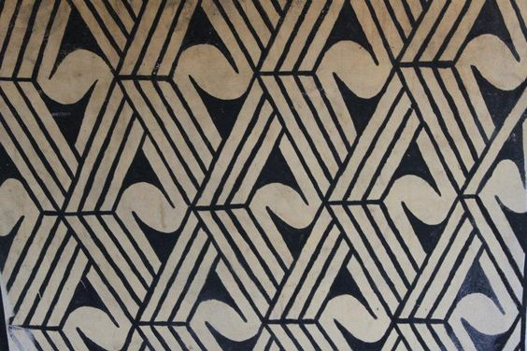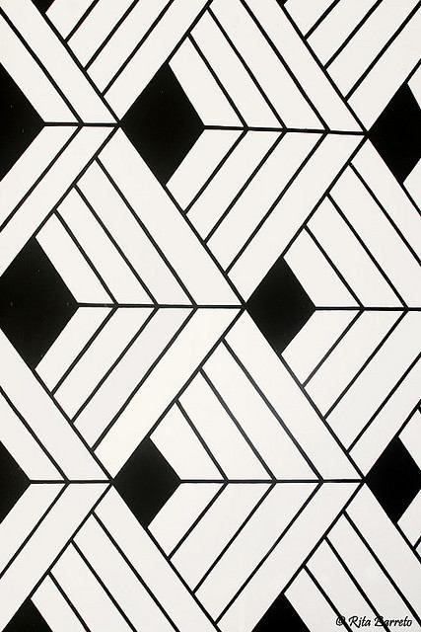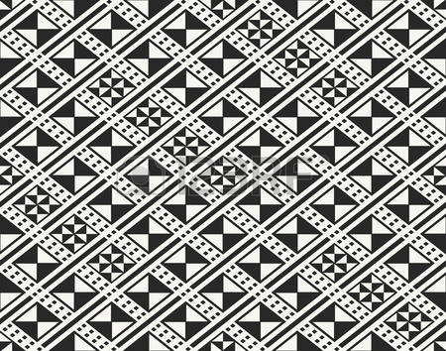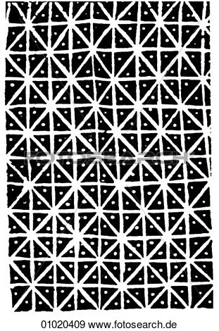

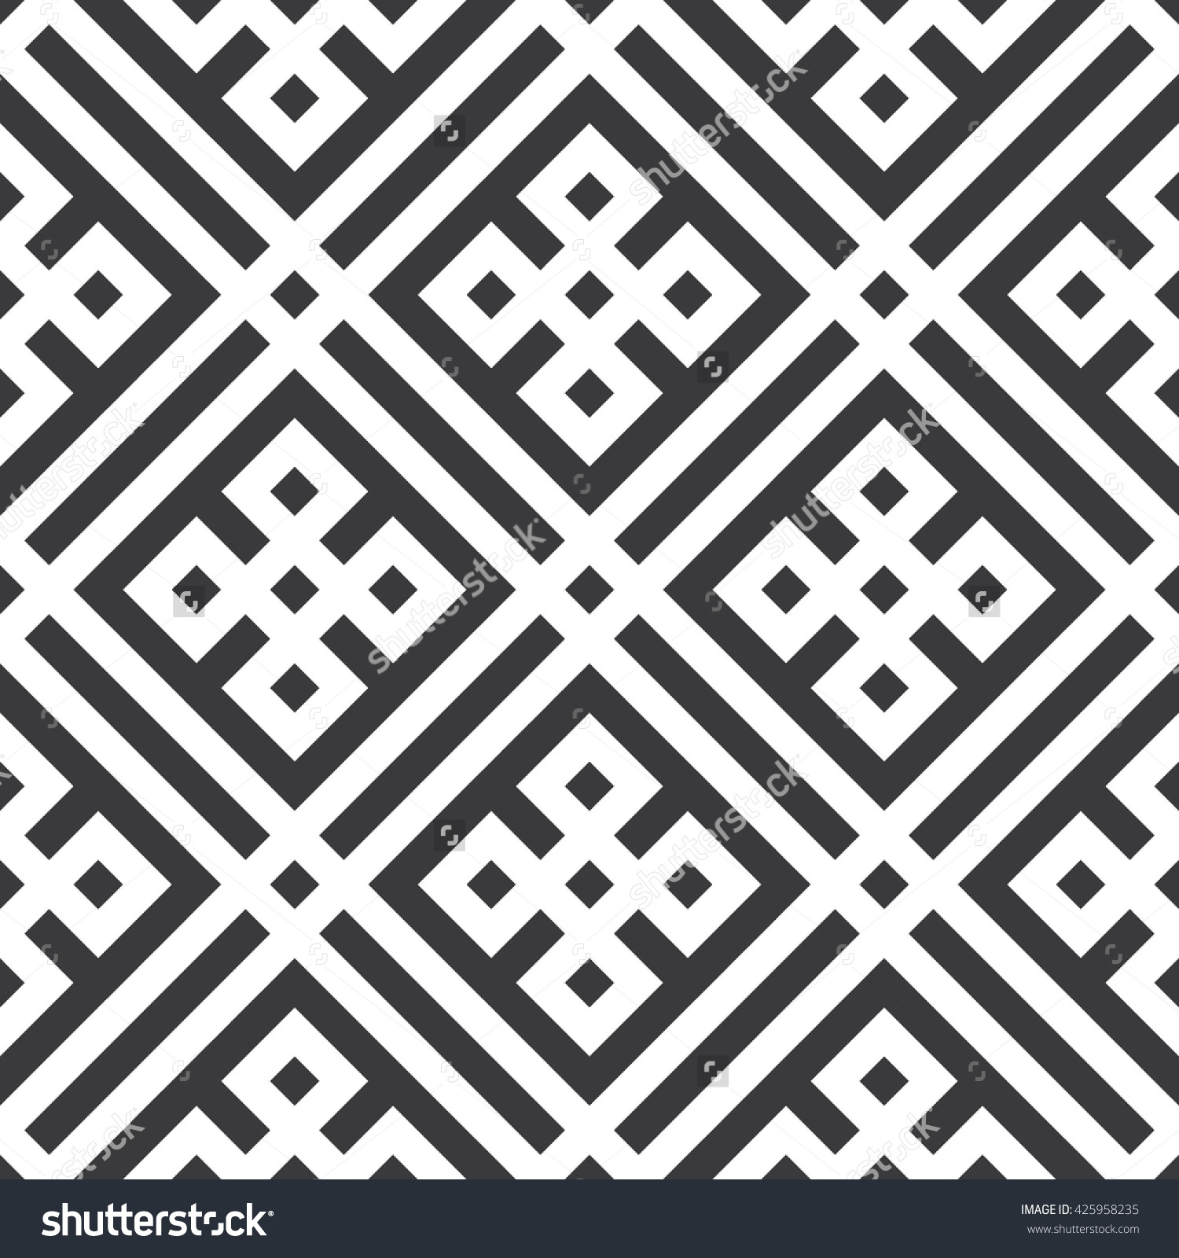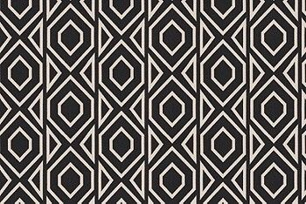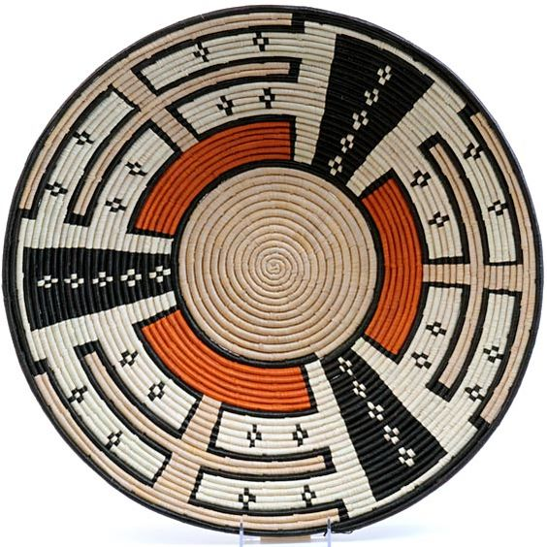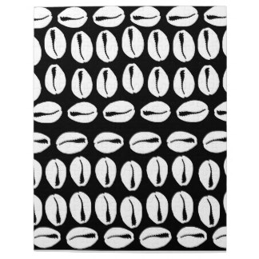

PATTERN IDEAS for -Mexican Folk/ Talavera patterns : These are Organic, Outlined, cartoonlike simple organic shapes of flowers, animals and abstractions
COLORS: Bright Saturated Color
Ideal Materials: Traditionally Red Clay with colorful patterns on White Background, but Bright Underglazes over white BG is fine
Methods: Templates, Stencils or freehand

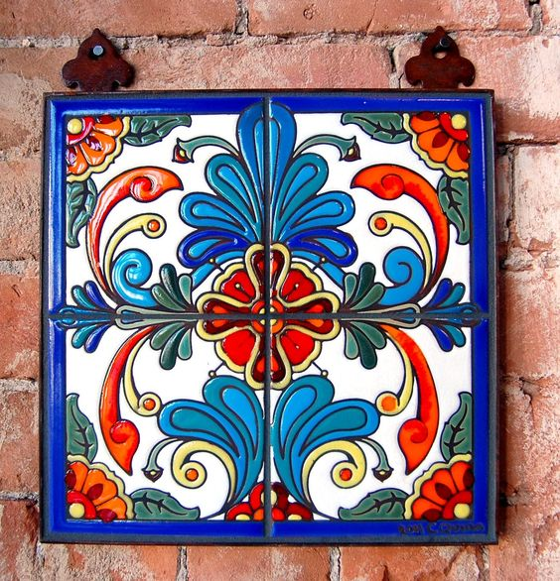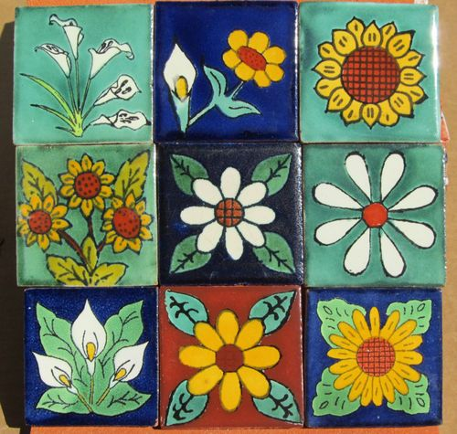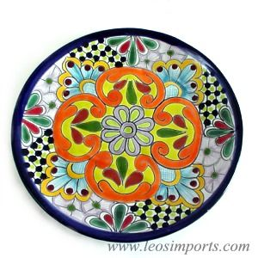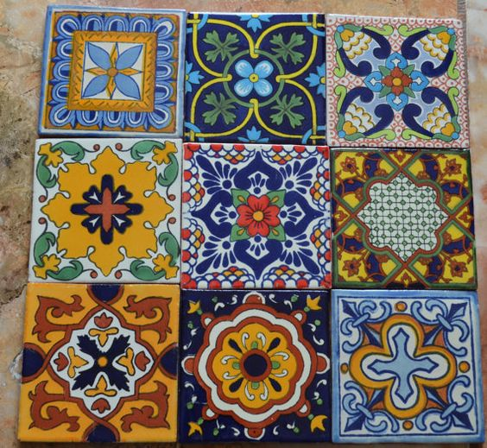

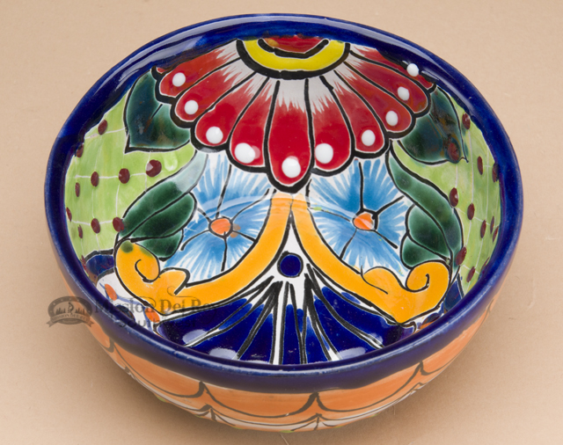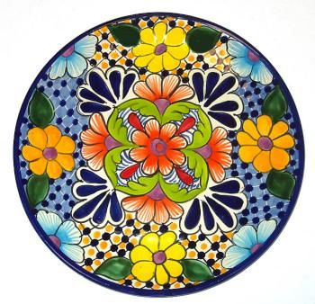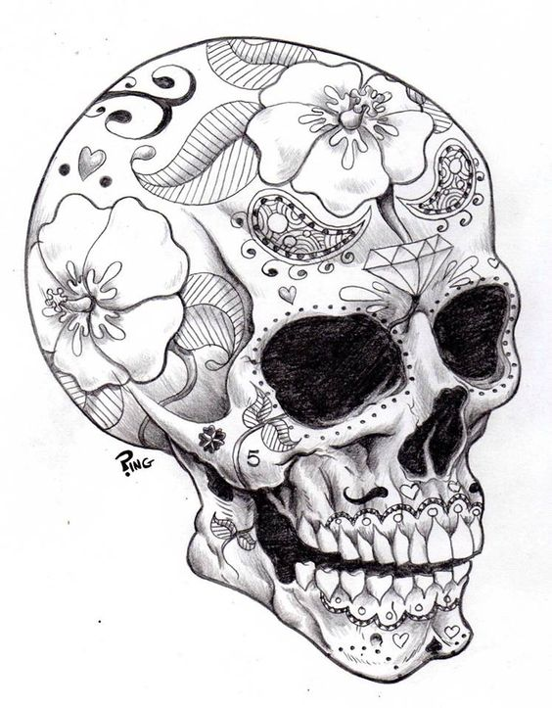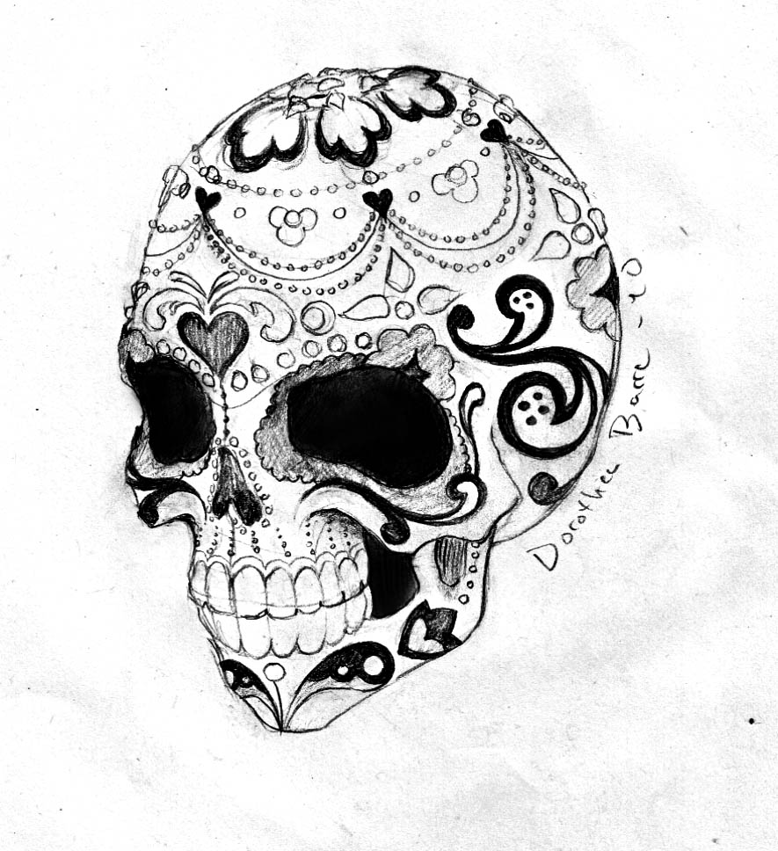

Mexican Patterns, Con’t
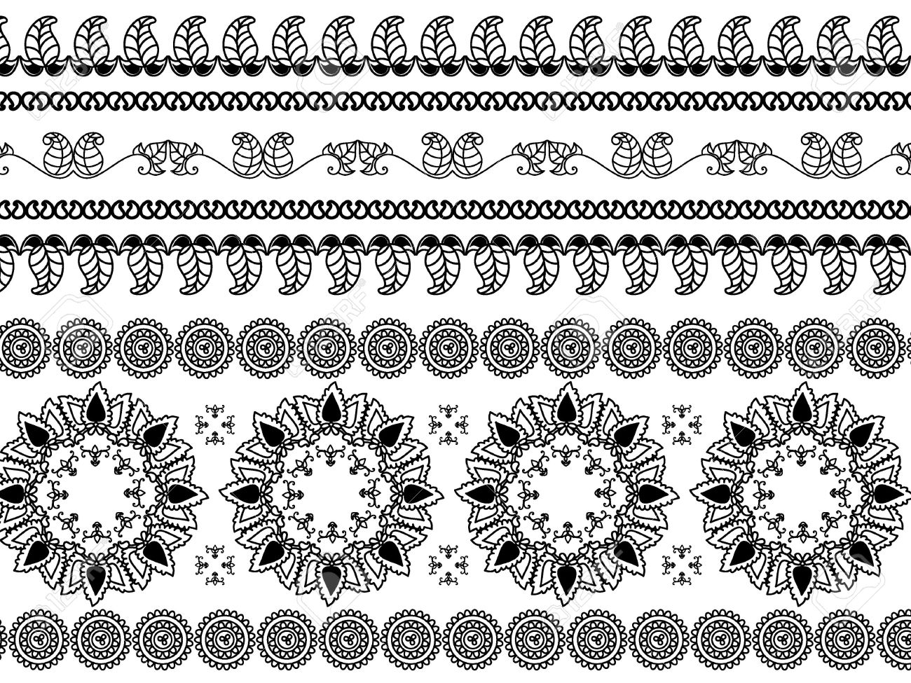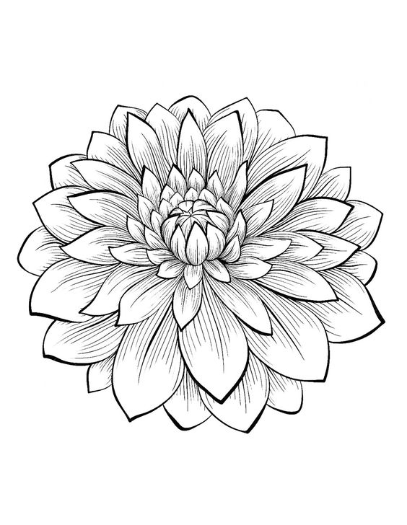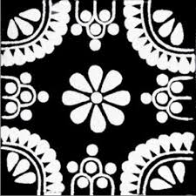

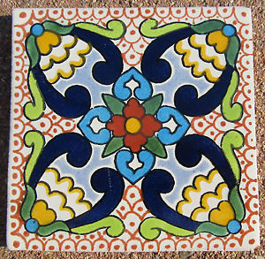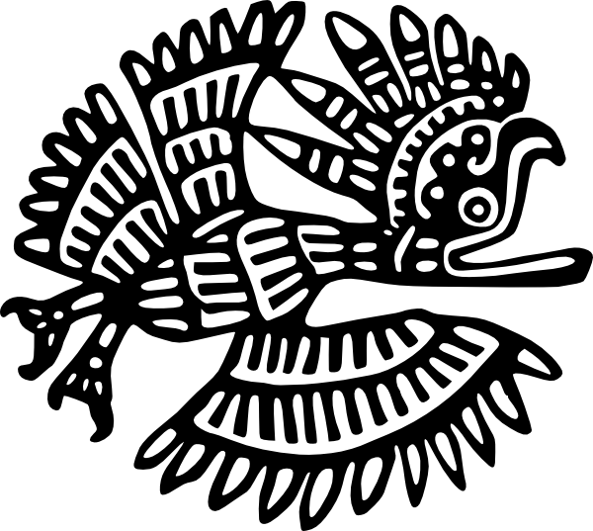

VIETNAMESE-PATTERNS: Motif Based: Sometimes Mythological themes: Dragons, Phoenix, Birds, Fish Themes. Sometimes mixed with Geometric Backgrounds
Sometimes organic patterns are abstracted and repeated in a tight, abstracted pattern like waves, fish, etc
Colors: Blue and White on porcelain, repeating patterns on red earthenware, colors are generally watered down/ muted/ or solid and few.
Materials: For Blue and white, best to use a white/ lighter claybody and underglazes
Methods: Tracing/ Stencil or freehand

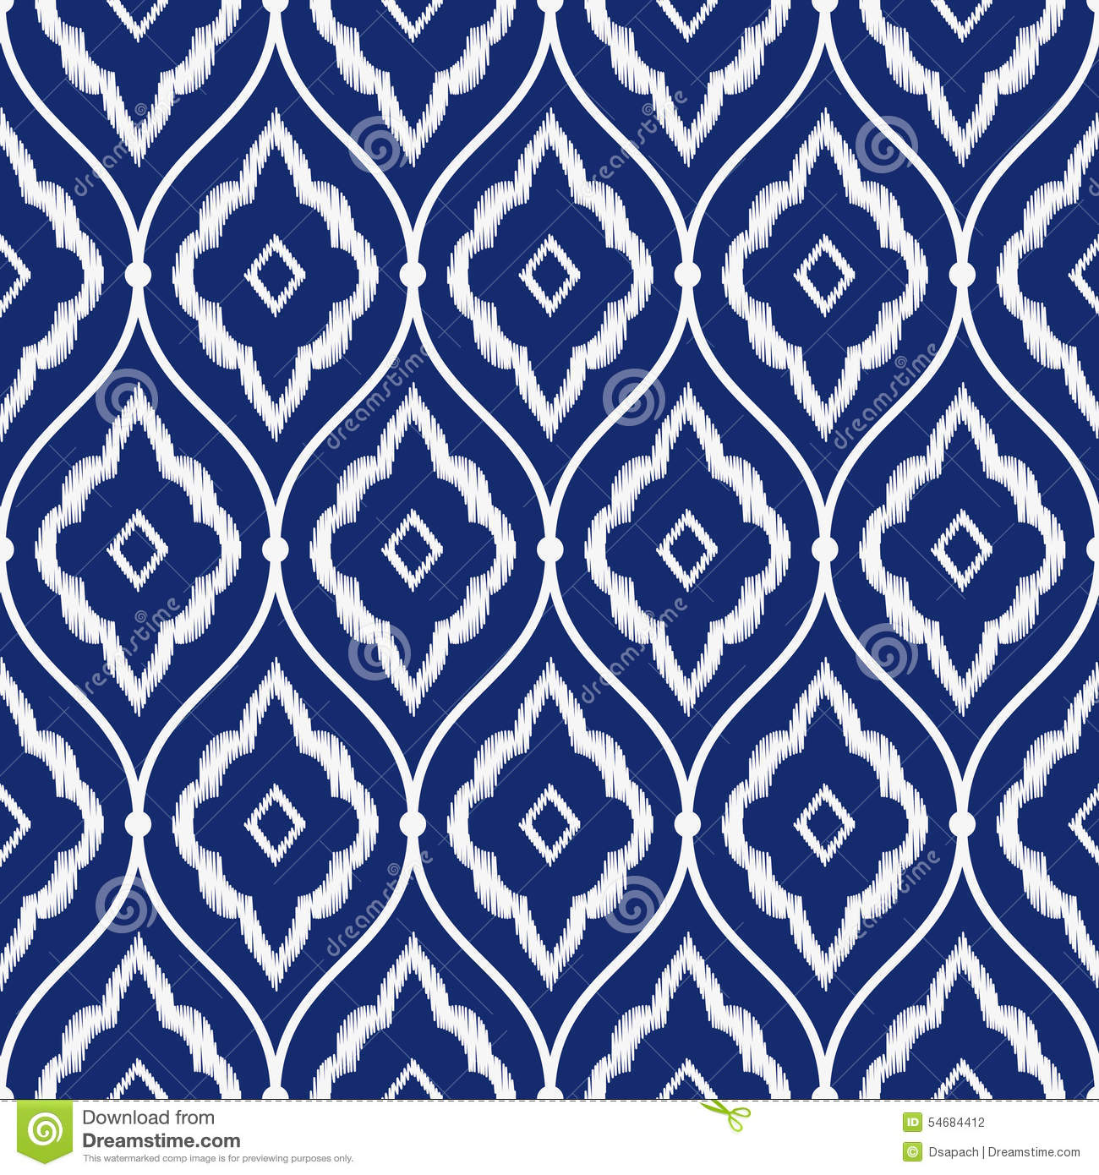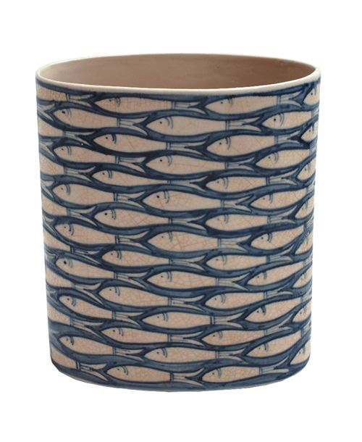

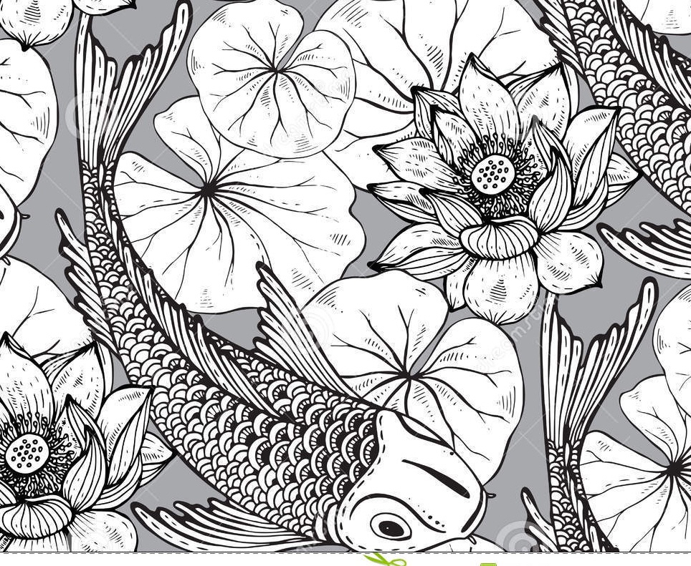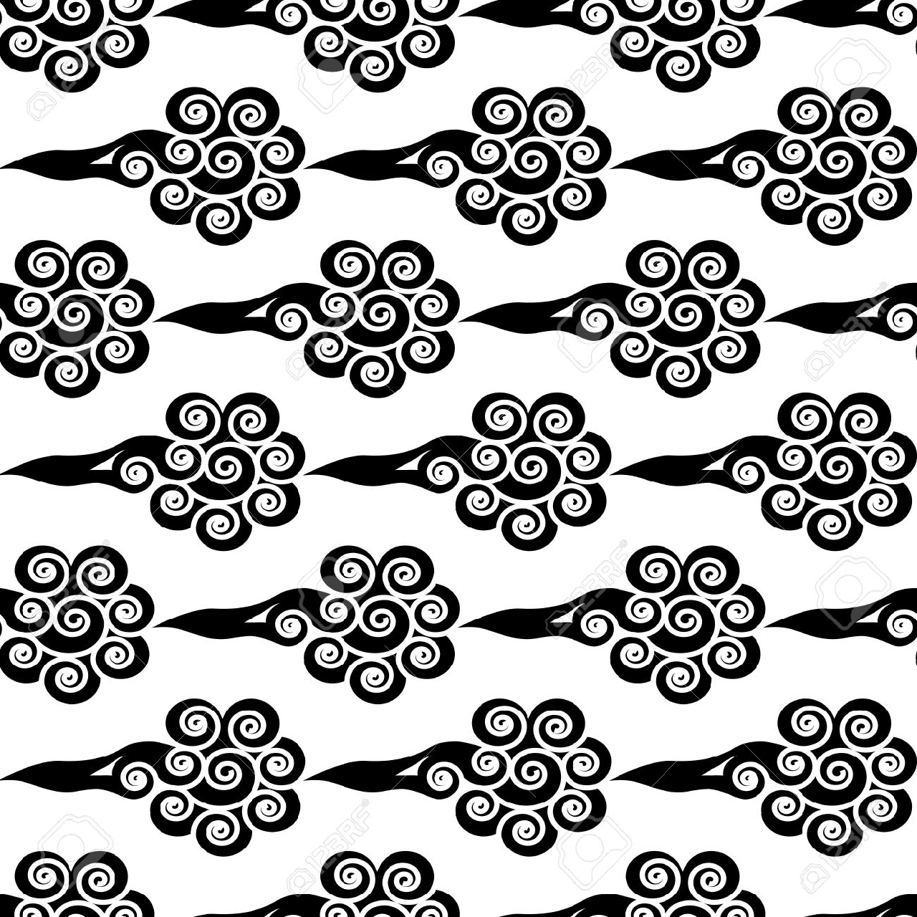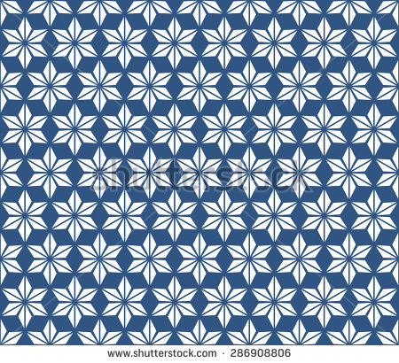
VIETNAMESE PATTERNS/ SUBJECTS- CON’T
