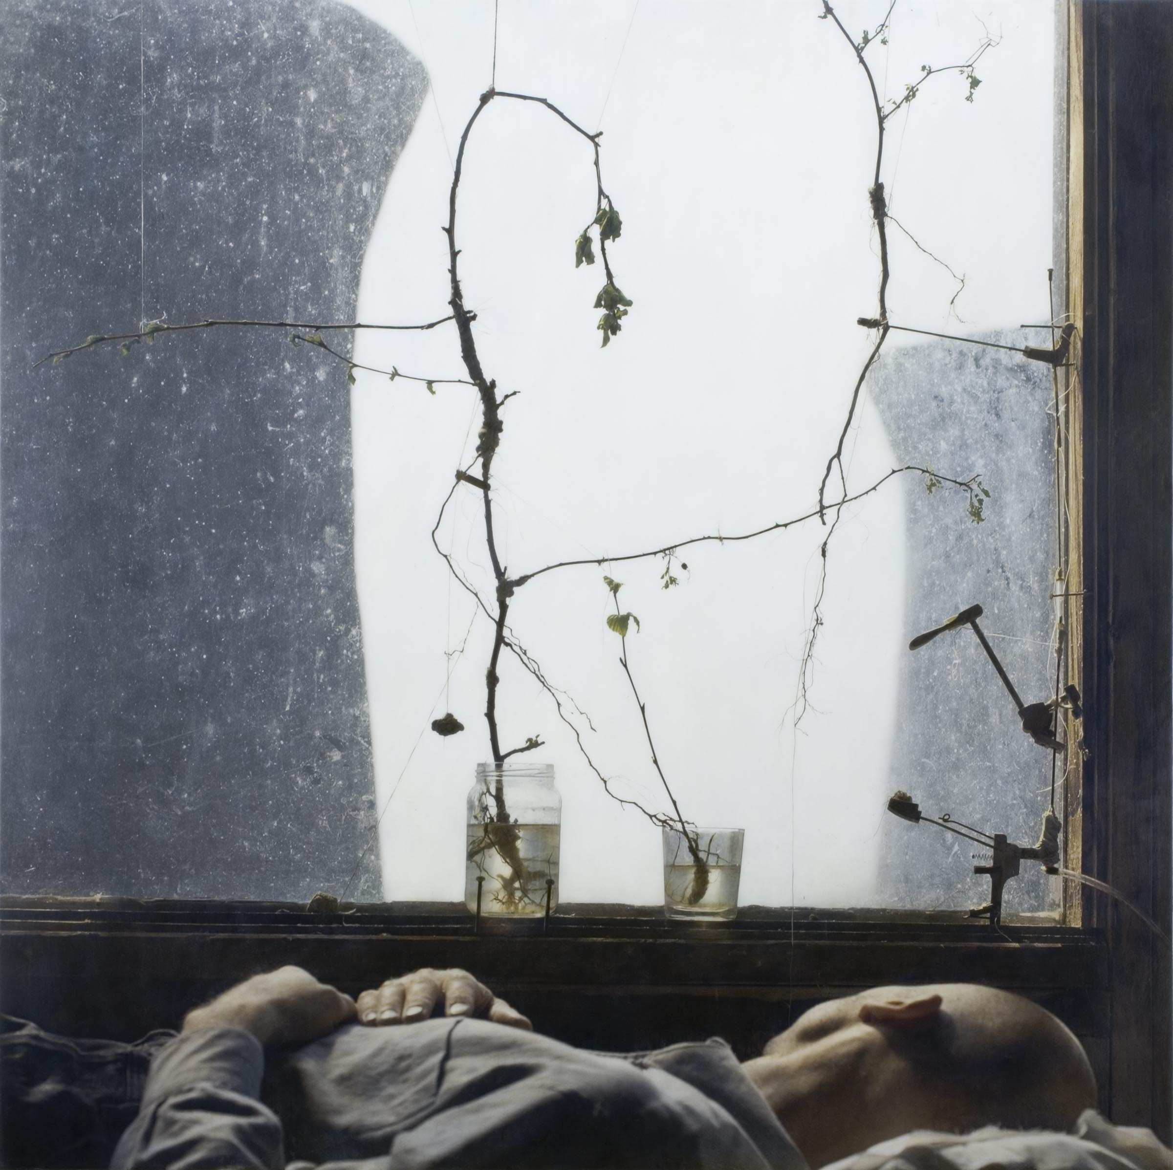
Robert and Shana ParkeHarrison (American, b. 1968 and 1964)
Gray Dawn, 2006
C-print on aluminum with acrylics
Collection Nerman Museum of Contemporary Art, 2007.42
Gift of Marti and Tony Oppenheimer and the Oppenheimer Brothers Foundation

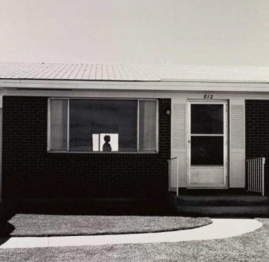
Robert Adams (American, b. 1937)

Colorado Springs, Colorado, 1968
gelatin silver print
Collection Nerman Museum of Contemporary Art, 95.25

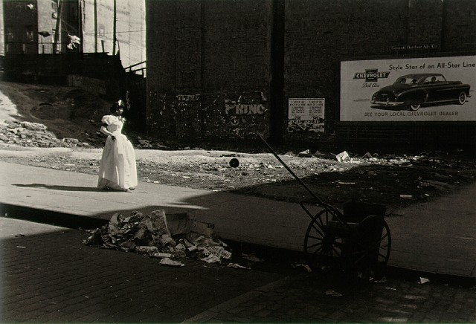Roy DeCarava (American, b. 1919 - d. 2009)

Graduation, New York, 1949, 1982
gelatin silver print
Collection Nerman Museum of Contemporary Art 90.3

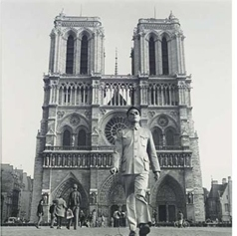

Tseng Kwong Chi (Chinese, b. 1950 - d. 1990)
Paris, France (Notre Dame), 1983
vintage gelatin silver print
Collection Nerman Museum of Contemporary Art, 99.1

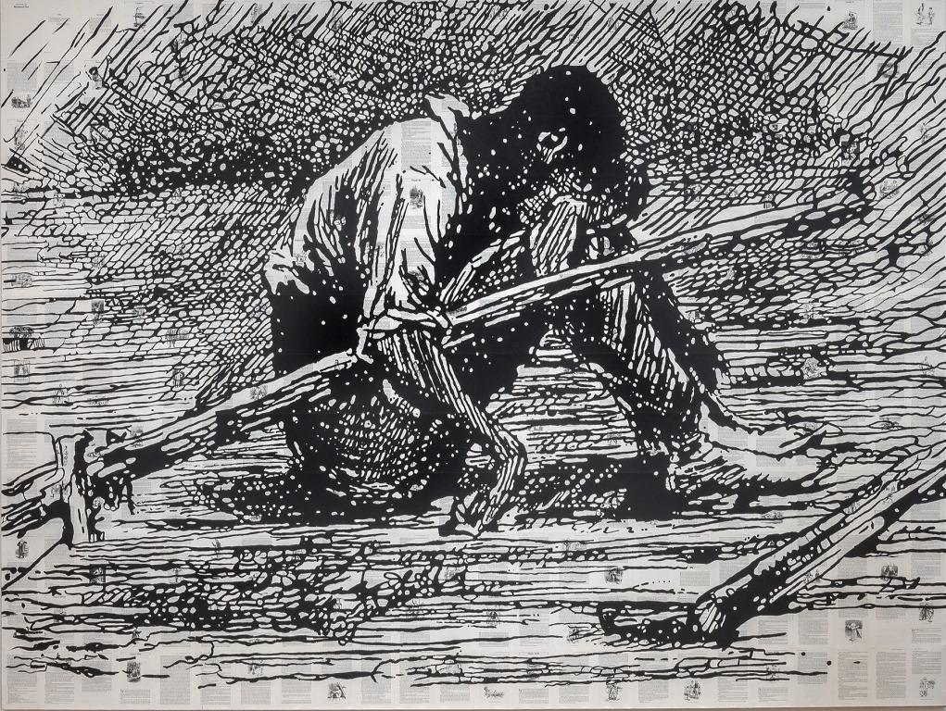
Tim Rollins (American, b. 1955 – d. 2017)
The Adventures of Huckleberry Finn, 1998
Mixed media on canvas
Collection Nerman Museum of Contemporary Art, 2009.76, Gift of Sari Haenisch, Kansas City, MO

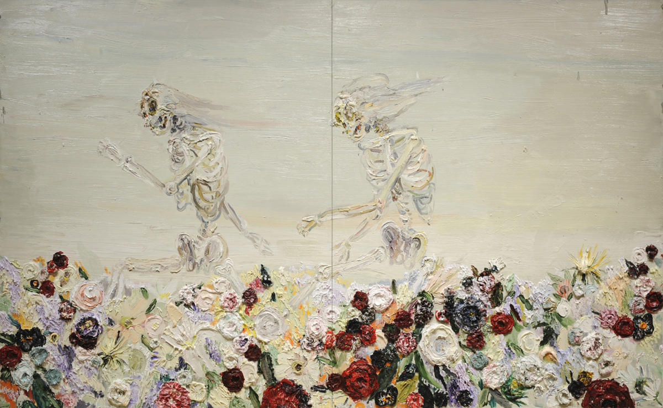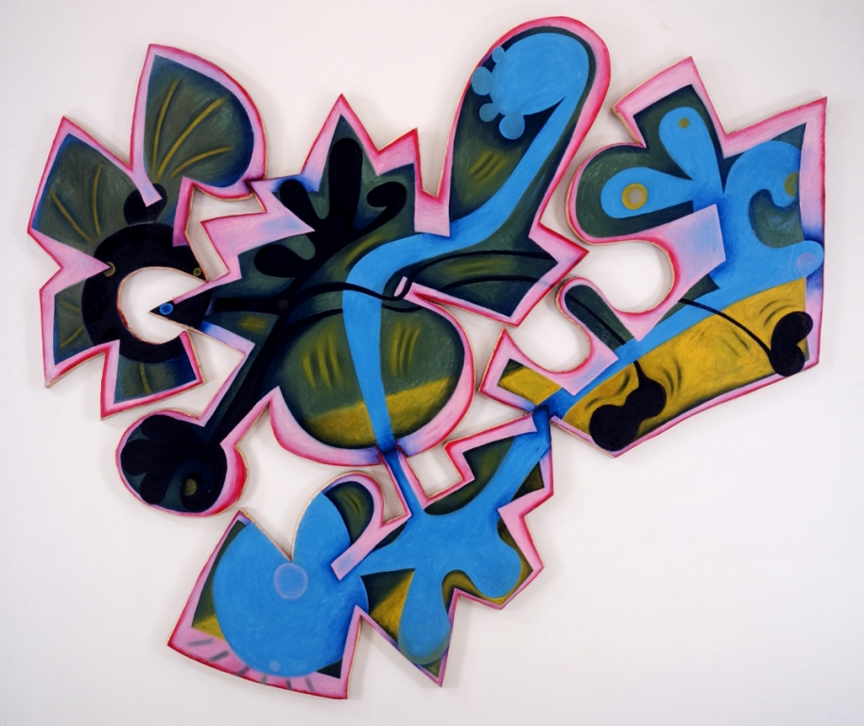
Allison Schulnik (American, b. 1978)
Skipping Skeletons, 2008
Oil on canvas
Collection Nerman Museum of Contemporary Art, 2008.20, Gift of Marti and Tony Oppenheimer, Los Angeles, CA

Elizabeth Murray (American, b. 1940-d. 2007)
Landing, 1999
Oil on canvas
Collection Nerman Museum of Contemporary Art, 1999.06, Gift of JCCC Gallery Associates
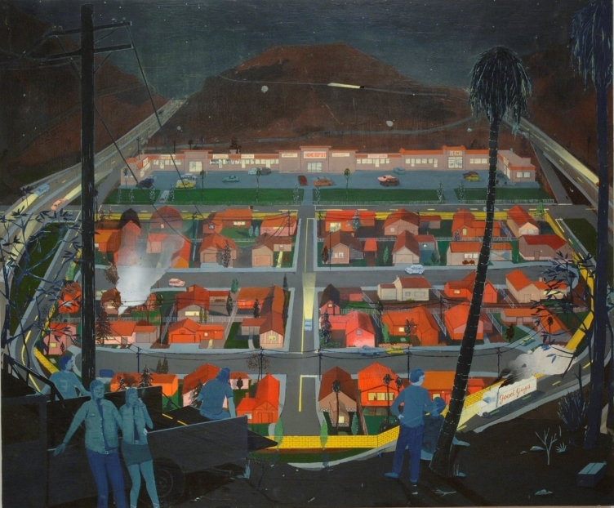
Jules de Balincort (French American, b. 1972)
Temporary Drop Out, 2003
Oil, spray paint, pen on board
Collection Nerman Museum of Contemporary Art, 2004.25

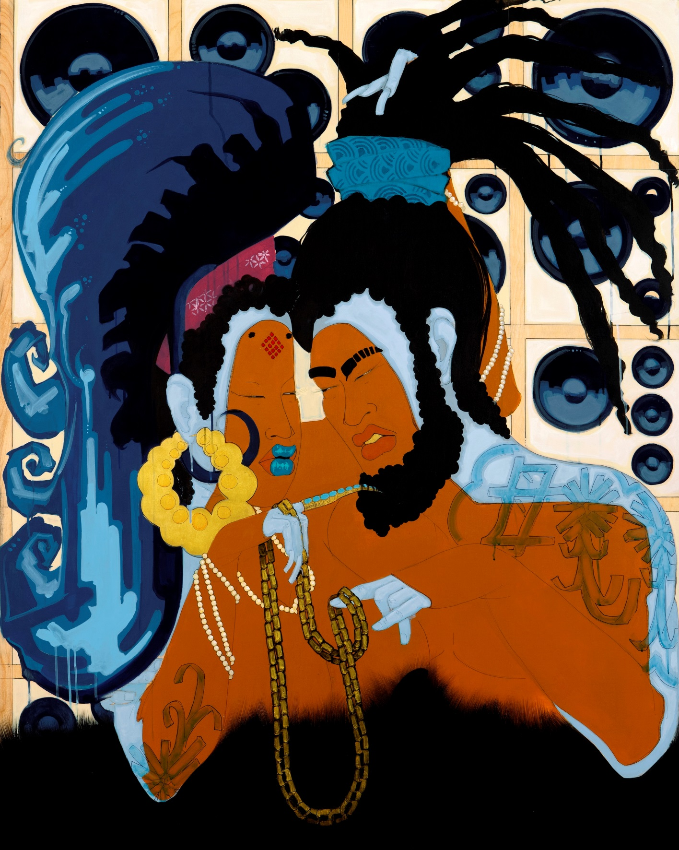
Iona Rozeal Brown (American, b. 1966)
POD 444, Lynxes and Dropses (Song of Solomon 4:1,9,5:16), 2013
Acrylic, ink, krink and graphite on wood panel
Collection Nerman Museum, Gift of the H. Tony and Marti Oppenheimer Foundation

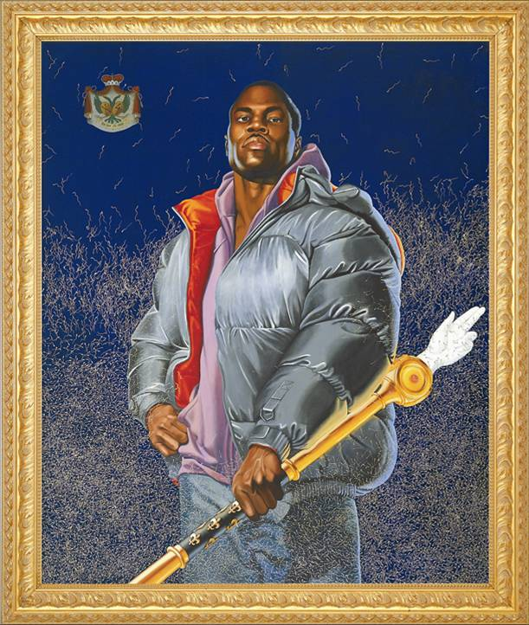

Kehinde Wiley (American, b. 1977)
Alexander the Great (Variation), 2005
Oil and enamel on canvas
Collection Nerman Museum of Contemporary Art, 2005.29
Gift of Marti and Tony Oppenheimer and the Oppenheimer Brothers Foundation

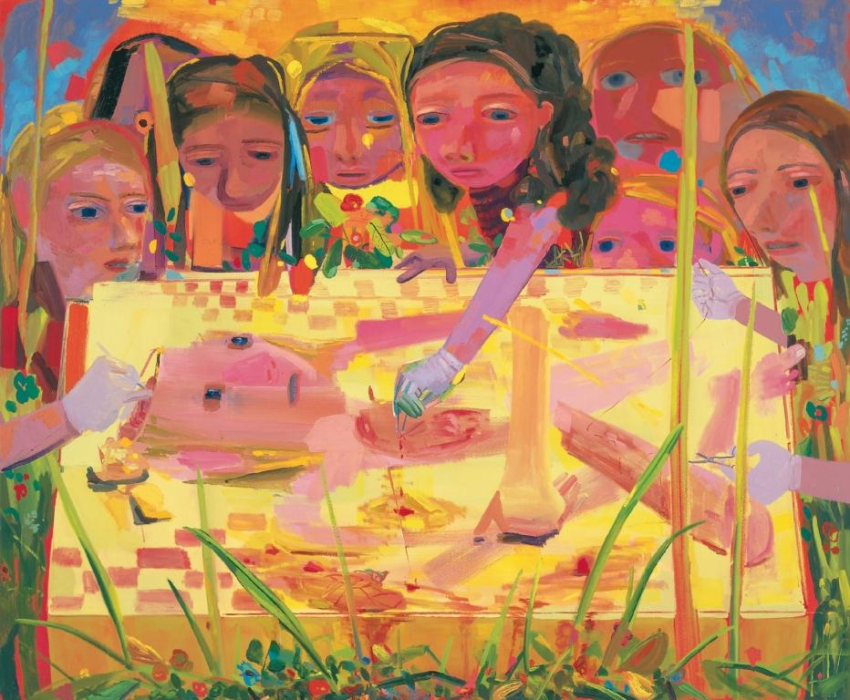
Dana Schutz (American, b. 1974)
Surgery, 2004
Oil on canvas
Collection Nerman Museum of Contemporary Art, 2004.15
Gift of Marti and Tony Oppenheimer and the Oppenheimer Brothers Foundation
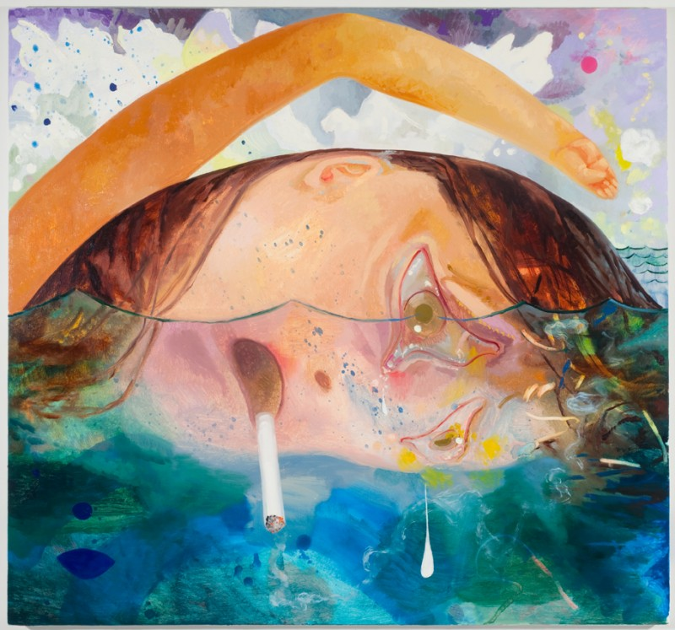Dana Schutz (American, b. 1976)
Swimming, Smoking, Crying, 2009
Oil on canvas
Collection Nerman Museum of Contemporary Art, 2010.01
Gift of Marti and Tony Oppenheimer and the Oppenheimer Brothers Foundation

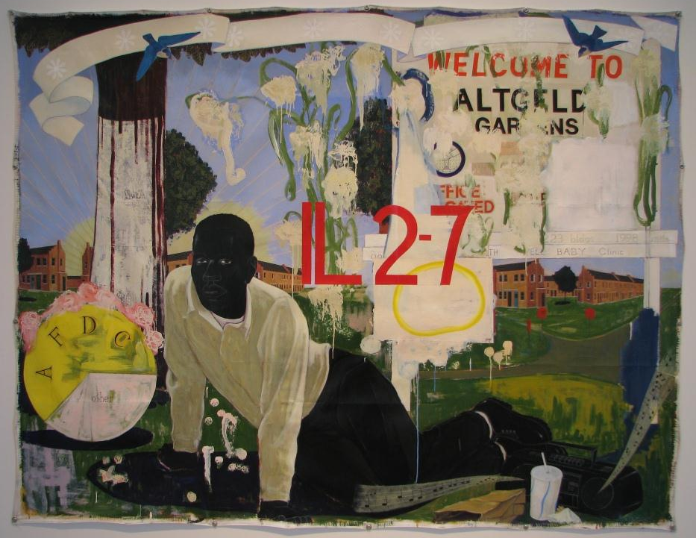
Kerry James Marshall (American, b. 1955)
Untitled (Altgeld Gardens), 1995
Acrylic and collage on canvas
Collection Nerman Museum of Contemporary Art, 1999.16

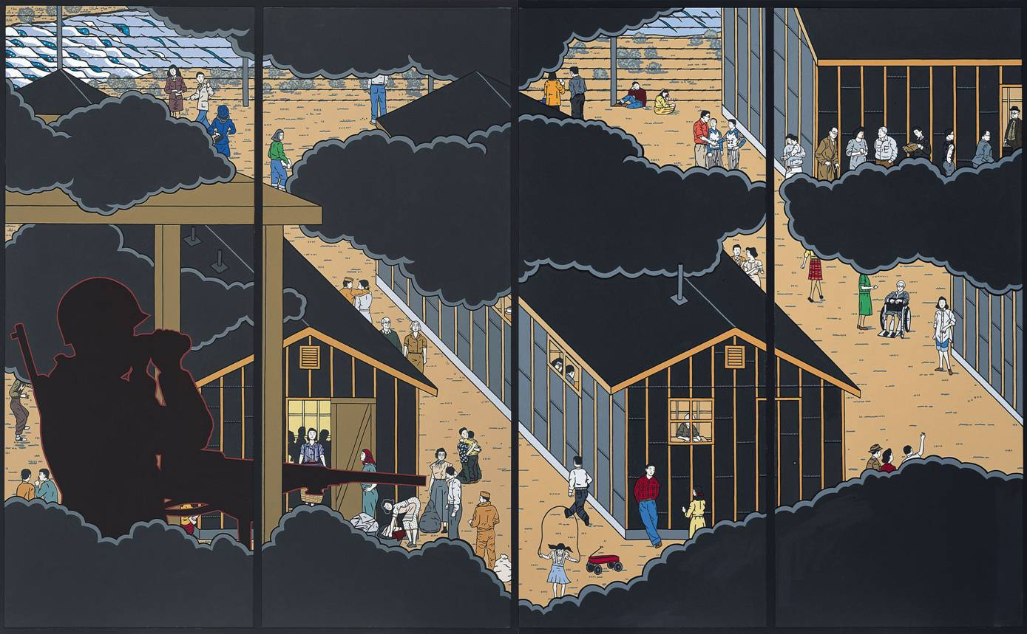
Roger Shimomura (American, b. 1939)
American Infamy, 2006
Acrylic on canvas panels
Collection Nerman Museum of Contemporary Art, 2006.15
Acquired with funds provided by JCCC and Marti and Tony Oppenheimer and the Oppenheimer Brothers Foundation

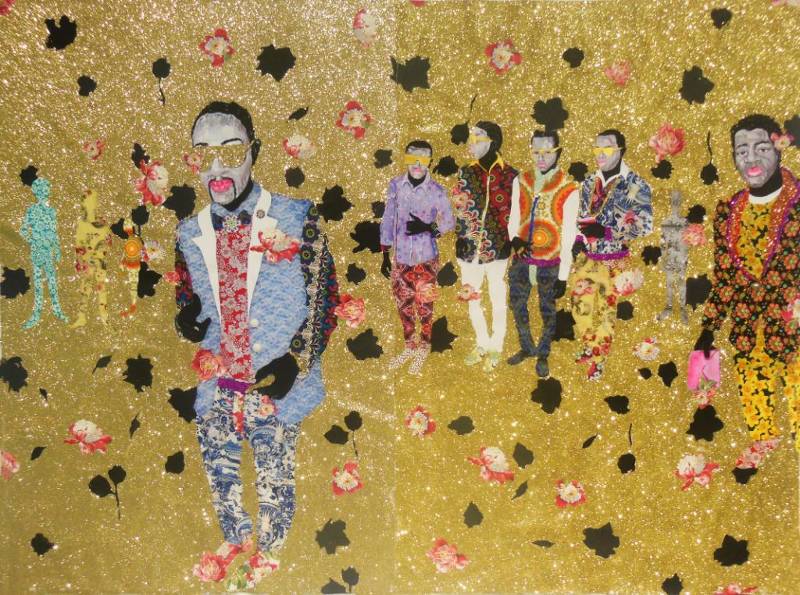
Ebony G. Patterson (Jamaican, b. 1981)
Untitled Lightz II, 2013
Mixed media on paper
Collection Nerman Museum of Contemporary Art, 2014.03
Gift of the H Tony and Marti Oppenheimer Foundation

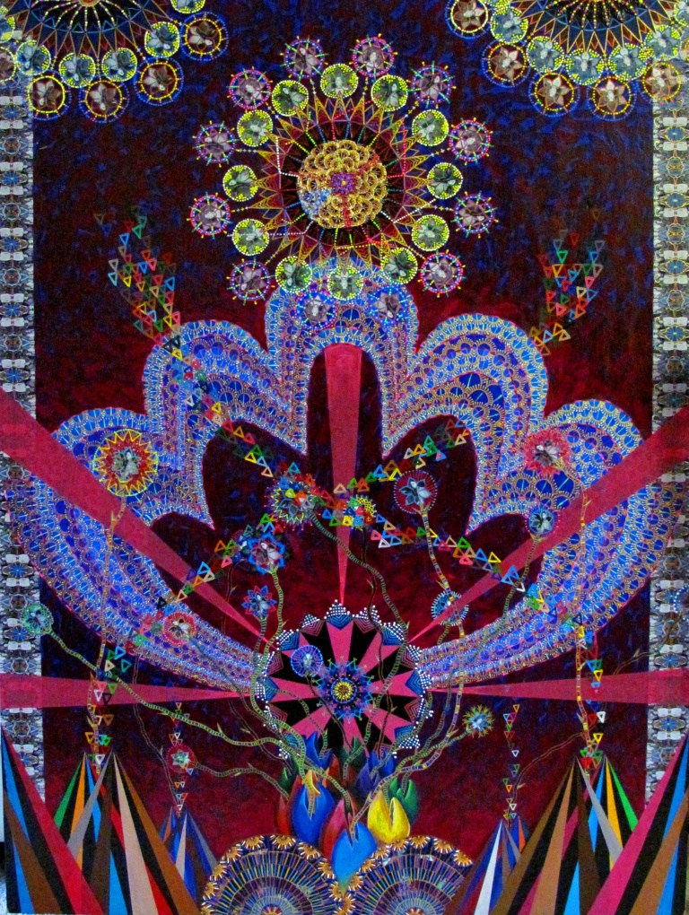
Asad Faulwell (American, b. 1982)
Mujahidat #11, 2010
Acrylic and paper on canvas
Collection Nerman Museum of Contemporary Art, 2011.12
Gift of Marti and Tony Oppenheimer, Los Angeles, CA

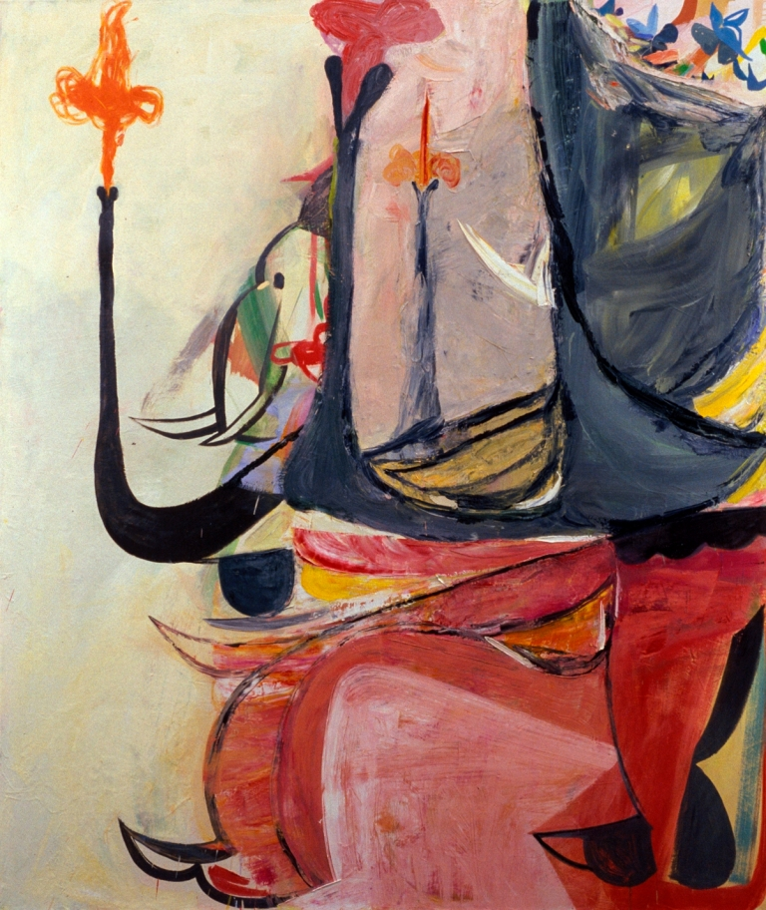

Amy Sillman (American, b. 1955)
Elephant, 2005
Oil on canvas
Collection Nerman Museum of Contemporary Art, 2005.30
Gift of Marti and Tony Oppenheimer and the Oppenheimer Brothers Foundation

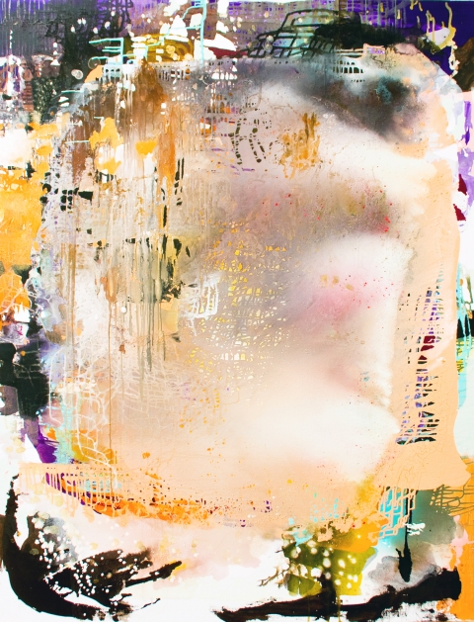
Jackie Saccoccio (American, b. 1963)
Portrait (Genovese), 2013
Oil and mica on linen
Collection Nerman Museum of Contemporary Art, 2013.16

