Table of Contents | Life of Henrietta | Life of Cells | Lacks Family | Deborah & Skloot
Prologue: The Woman in the Photograph |  |  |  | (Skloot)
PT. 1 LIFE
1 The Exam ... 1951 | *
2 Clover ... 1920-1942 | *
3 Diagnosis and Treatment ... 1951 | * | *
4 The Birth of HeLa ... 1951 | * | *
5 "Blackness Be Spreadin All Inside" ... 1951 | *
6 "Lady's on the Phone" ... 1999 |  |  | * | *
7 The Death and Life of Cell Culture ... 1951 | * | *
8 "A Miserable Specimen" ... 1951 | * |  | *
9 Turner Station ... 1999 |  |  |  | *
10 The Other Side of the Tracks ... 1999 |  |  | ** | *
11 "The Devil of Pain Itself" ... 1951 | *
PT. 2 DEATH
12 The Storm ... 1951 | *
13 The HeLa Factory ... 1951-1953 |  | *
14 Helen Lane ... 1953-1954 |  | *
15 "Too Young to Remember" ... 1951-1965 |  |  | *
16 "Spending Eternity in the Same Place" ... 1999 |  |  | ** | *
17 Illegal, Immoral, and Deplorable ... 1954-1966 |  | *
18 "Strangest Hybrid" ... 1960-1966 |  | *
19 "The Most Critical Time on This Earth Is Now" 1966-1973 |  |  | *
20 The HeLa Bomb… 1966 |  | *
21 Night Doctors … 2000 |  |  | *
22 "The Fame She So Richly Deserves" ... 1970-1973 |  | *
PT. 3 IMMORTALITY
23 "It's Alive" ... 1973-1974 |  | * | *
24 "Least They Can Do" ... 1975 |  | * | *
25 "Who Told You You Could Sell My Spleen?" ... 1976-1988 |  | *
26 Breach of Privacy ... 1980-1985 |  |  | *
27 The Secret of Immortality ... 1984-1995 |  | *
28 After London ... 1996-1999 |  |  | *
29 A Village of Henriettas ... 2000 |  |  | * | *
30 Zakariyya ... 2000 |  |  | * | *
31 Hela, Goddess of Death ... 2000-2001 |  |  | * | *
32 "All That's My Mother" ... 2001 |  | * | * | *
33 The Hospital for the Negro Insane ... 2001 |  |  | * | *
34 The Medical Records ... 2001 |  |  | * | *
35 Soul Cleansing ... 2001 |  |  | * | *
36 Heavenly Bodies ... 2001 |  |  | * | *
37 "Nothing to Be Scared About" ... 2001 |  |  | * | *
38 The Long Road to Clover ... 2009 |  |  | * | *

A few samples of writing genres

Profile—person

- Medical profile of Henrietta Lacks, p. 16
- Biographical sketch of Henrietta Lacks, Ch. 2, pp. 18-26
- Dr. George Gey, pp.38-40
- Sir Lord Keenan Cofield (con man) pp. 225-231
- Deborah, 250-258

Profile—place
- Lab, pp. 263-267
- Turner’s Station (1800 & 1940s), pp. 25-26
- Clover (modern), pp. 77-82

Narration
- The exam, pp. 13-17
- Hospital for the Negro Insane, pp. 268-278
- The medical records skirmish, pp. 279-285

Expository/informative writing
- Cervical carcinoma, pp. 28-30
- Birth of HeLa, pp. 35-38
- HeLa production, pp. 93-104
- Cell mutation and adaptation, pp. 214-217

Persuasive
- Did race affect Henrietta Lacks’ medical treatment? Pp. 63-66
- How should medical testing subjects be selected and informed? Pp. 125-136
- Who owns tissues taken for medical exams? Pp.199-206
- Who can access private records? Pp. 207-211

Writing from Sources*
- “Helen Lane” pp. 105-109
- “The Strangest Hybrid” pp. 137-143
- “After London” pp. 218-231

Skloot does not use formal academic citation, but she kept notes in notebooks and recorded all conversations (with the knowledge of all participants). She also took thousands of pictures during her research process.

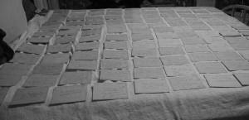

Notecards Skloot used to order ideas in book (more impressive in color—JPG of color photo in LOR)

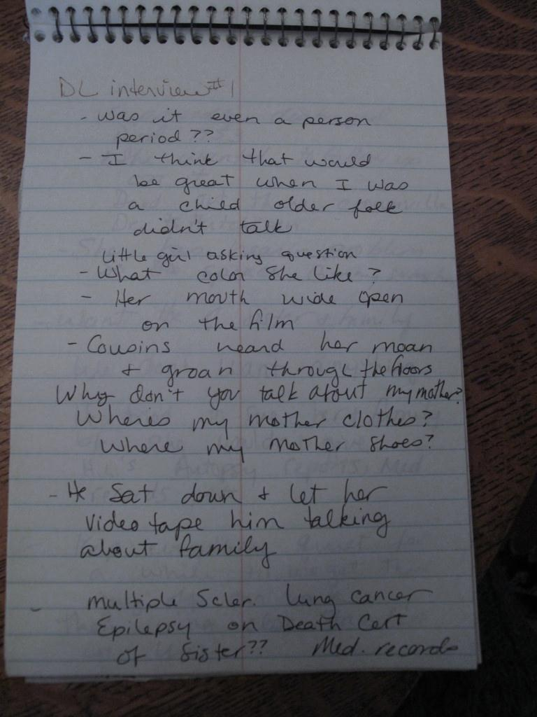 Notes from Skloot’s first call to Deborah

